Install Git

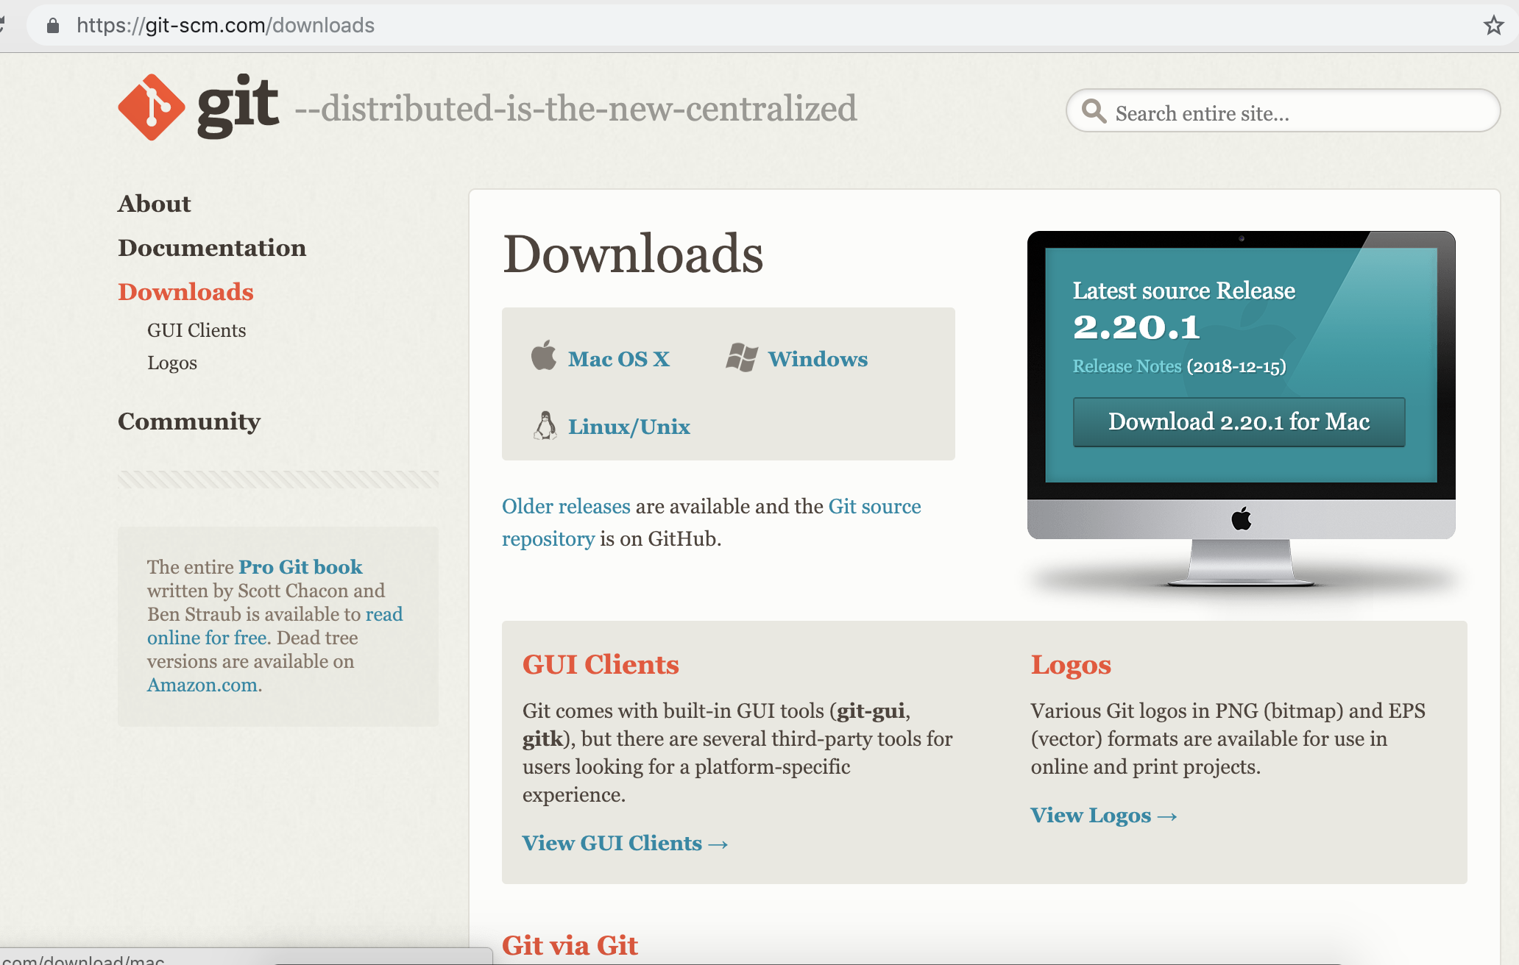

Install LTS NodeJs

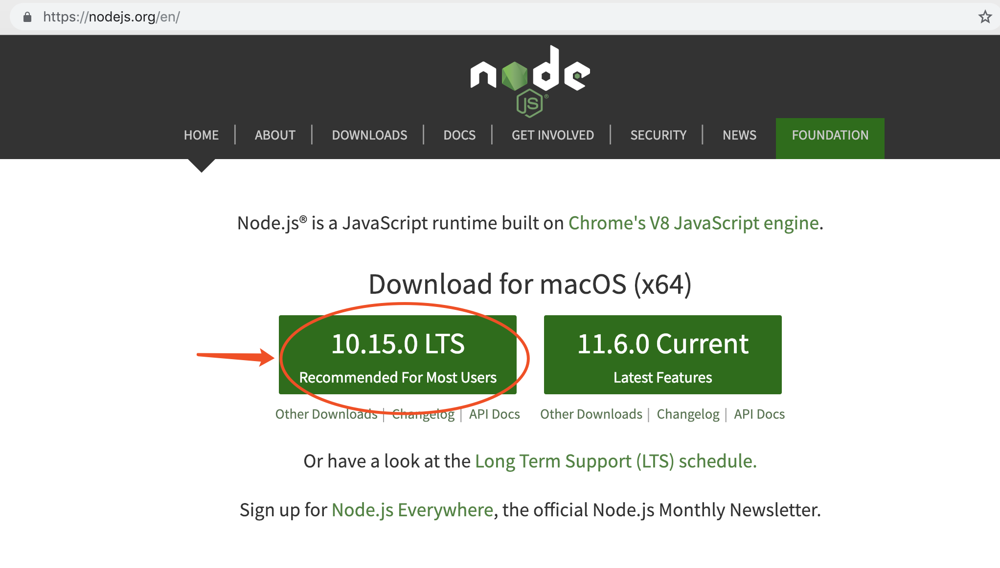

**configure the PATH environment**

add “./node_modules/.bin/” as last path

open terminal and check “.bash_profile”

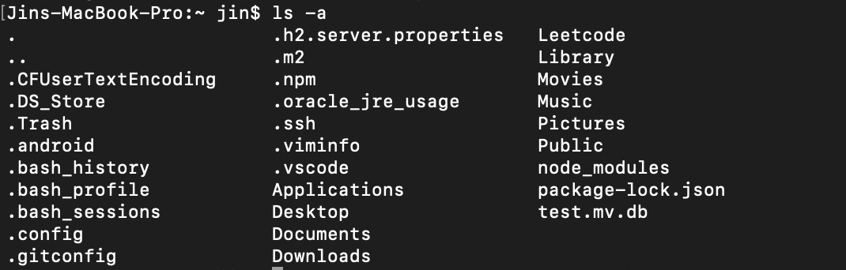

vim .bash_profile.

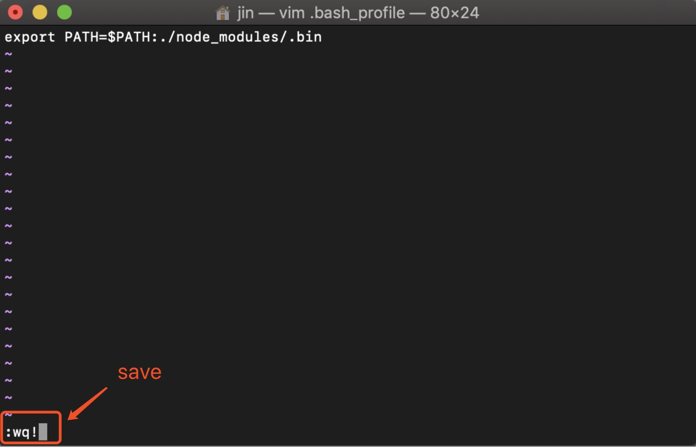

source .bash_profile.

echo $PATH

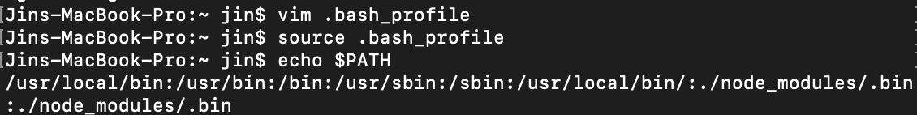

**Chrome Dev Tools Console**

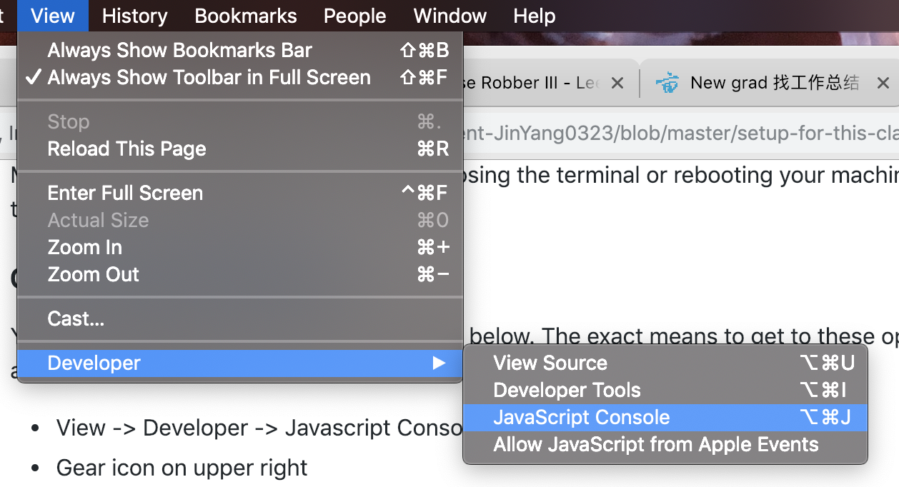

Follow Instruction

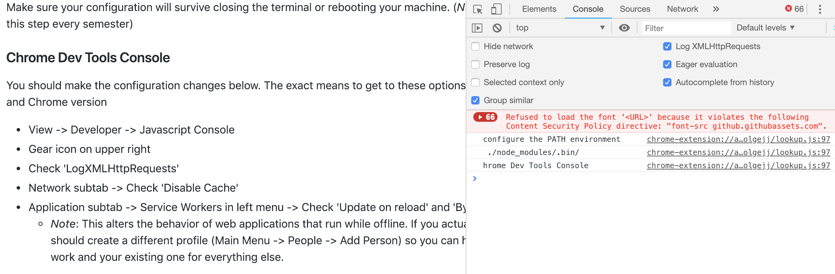

## Making sure it all works

clone the repository and change into the samples/setup-test directory

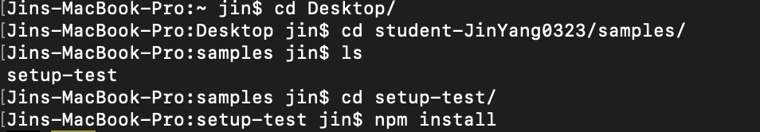

Edit list.js and add your name, NEU ID, and github id to the list

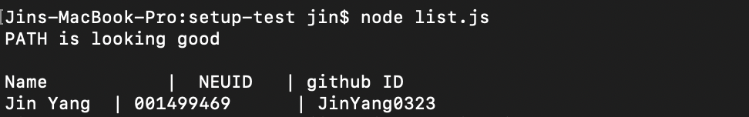

Add the file to Git

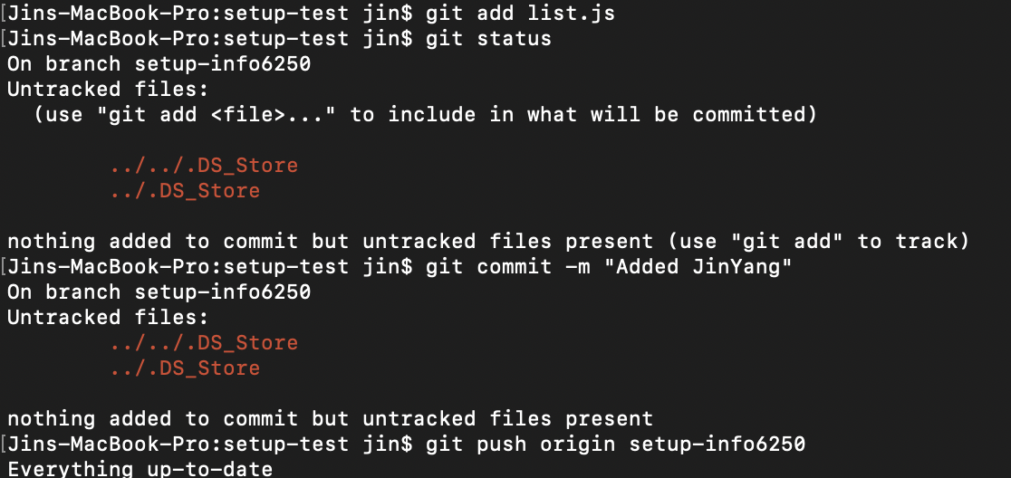

Go to the github page for this repository and create a Pull Request

